DATA STRUCTURE
ASSIGNMENT #3
Muhammad Ayaan Amir
F24-0767
TASK#1:

Main.cpp:
#include "task1.h"
#include <iostream>
using namespace std;

int main()
{

int arr1[] = { 10, 5, 15, 2, 7, 12, 20 };
int size1 = sizeof(arr1) / sizeof(arr1[0]);

BinaryTree<int> tree1;
tree1.BuildTree(arr1, size1);

cout << "===== TREE 1 (Perfect BST) =====\n";
cout << "InOrder (Recursive): "; tree1.InOrder();
cout << "PreOrder (Recursive): "; tree1.PreOrder();
cout << "PostOrder (Recursive): "; tree1.PostOrder();
cout << "LevelOrder: "; tree1.LevelOrder();
cout << "Is BST? " << (tree1.isBST() ? "Yes" : "No") << endl;
cout << "Height: " << tree1.Height() << endl;
cout << "Nodes at Level 2: " << tree1.NodesAtLevel(2) << endl;
cout << "------------------------------------\n\n";

int arr2[] = { 10, 15, 5, 2, 7, 12, 20 }; // invalid BST (15 is on the left of 10)
int size2 = sizeof(arr2) / sizeof(arr2[0]);

BinaryTree<int> tree2;
tree2.BuildTree(arr2, size2);

cout << "===== TREE 2 (Not a BST) =====\n";
cout << "InOrder (Recursive): "; tree2.InOrder();
cout << "PreOrder (Recursive): "; tree2.PreOrder();
cout << "PostOrder (Recursive): "; tree2.PostOrder();
cout << "LevelOrder: "; tree2.LevelOrder();
cout << "Is BST? " << (tree2.isBST() ? "Yes" : "No") << endl;
cout << "Height: " << tree2.Height() << endl;
cout << "Nodes at Level 3: " << tree2.NodesAtLevel(3) << endl;
cout << "------------------------------------\n\n";

int arr3[] = { 42 };
int size3 = sizeof(arr3) / sizeof(arr3[0]);

BinaryTree<int> tree3;
tree3.BuildTree(arr3, size3);

cout << "===== TREE 3 (Single Node) =====\n";
cout << "InOrder: "; tree3.InOrder();
cout << "Is BST? " << (tree3.isBST() ? "Yes" : "No") << endl;
cout << "Height: " << tree3.Height() << endl;
cout << "Nodes at Level 1: " << tree3.NodesAtLevel(1) << endl;
cout << "------------------------------------\n\n";

int arr4[] = { 10, 5, 0, 3, 0, 0, 0 };
int size4 = sizeof(arr4) / sizeof(arr4[0]);

BinaryTree<int> tree4;
tree4.BuildTree(arr4, size4);

cout << "===== TREE 4 (Left-Skewed) =====\n";
cout << "InOrder: "; tree4.InOrder();
cout << "PreOrder: "; tree4.PreOrder();
cout << "PostOrder: "; tree4.PostOrder();
cout << "Is BST? " << (tree4.isBST() ? "Yes" : "No") << endl;
cout << "Height: " << tree4.Height() << endl;
cout << "Nodes at Level 3: " << tree4.NodesAtLevel(3) << endl;
cout << "------------------------------------\n\n";

int arr5[] = { 10, 0, 20, 0, 0, 0, 30 }; // right child only
int size5 = sizeof(arr5) / sizeof(arr5[0]);

BinaryTree<int> tree5;
tree5.BuildTree(arr5, size5);

cout << "===== TREE 5 (Right-Skewed) =====\n";
cout << "InOrder: "; tree5.InOrder();
cout << "PreOrder: "; tree5.PreOrder();
cout << "PostOrder: "; tree5.PostOrder();
cout << "Is BST? " << (tree5.isBST() ? "Yes" : "No") << endl;
cout << "Height: " << tree5.Height() << endl;
cout << "Nodes at Level 3: " << tree5.NodesAtLevel(3) << endl;
cout << "------------------------------------\n\n";

return 0;
}

Task1.cpp

#include"task1.h"
#include <iostream>
#include <queue>
#include <stack>
#include <algorithm> // For std::max

// --- BNode Implementation ---

template<class DT>
BNode<DT>::BNode()
{
data = DT();
leftchild = nullptr;
rightchild = nullptr;
// data is uninitialized by default
}

template<class DT>
void BNode<DT>::setLeftChild(BNode<DT>* n)
{
leftchild = n;
}

template<class DT>
BNode<DT>* BNode<DT>::getLeftChild()
{
return leftchild;
}

template<class DT>
void BNode<DT>::setRightChild(BNode<DT>* n)
{
rightchild = n;
}

template<class DT>
BNode<DT>* BNode<DT>::getRightChild()
{
return rightchild;
}

template<class DT>
void BNode<DT>::setData(DT pdata)
{
data = pdata;
}

template<class DT>
DT BNode<DT>::getData()
{
return data;
}

// --- BinaryTree Implementation ---

template<class DT>
BinaryTree<DT>::BinaryTree()
{
root = nullptr;
}

template<class DT>
void BinaryTree<DT>::BuildTree(DT* Arr, int Size)
{
if (Size == 0 || Arr[0] == 0) // Assuming 0 is the sentinel for null
{
root = nullptr;
return;
}

// Create root
root = new BNode<DT>();
root->setData(Arr[0]);

// Queue for level-order construction
std::queue<BNode<DT>*> q;
q.push(root);

int i = 1; // Start from the second element (index 1)
while (i < Size && !q.empty())
{
BNode<DT>* currentParent = q.front();
q.pop();

// Handle left child
if (Arr[i] != 0) // Assuming 0 is sentinel
{
BNode<DT>* left = new BNode<DT>();
left->setData(Arr[i]);
currentParent->setLeftChild(left);
q.push(left);
}
i++;

if (i >= Size) break; // Array bounds check

// Handle right child
if (Arr[i] != 0) // Assuming 0 is sentinel
{
BNode<DT>* right = new BNode<DT>();
right->setData(Arr[i]);
currentParent->setRightChild(right);
q.push(right);
}
i++;
}
}

// --- Recursive Traversals ---

template<class DT>
void BinaryTree<DT>::PostOrder()
{
PostOrderRecursive(root);
std::cout << std::endl;
}

template<class DT>
void BinaryTree<DT>::PostOrderRecursive(BNode<DT>* node)
{
if (node == nullptr)
{
return;
}
PostOrderRecursive(node->getLeftChild());
PostOrderRecursive(node->getRightChild());
std::cout << node->getData() << " ";
}

template<class DT>
void BinaryTree<DT>::PreOrder()
{
PreOrderRecursive(root);
std::cout << std::endl;
}

template<class DT>
void BinaryTree<DT>::PreOrderRecursive(BNode<DT>* node)
{
if (node == nullptr)
{
return;
}
std::cout << node->getData() << " ";
PreOrderRecursive(node->getLeftChild());
PreOrderRecursive(node->getRightChild());
}

template<class DT>
void BinaryTree<DT>::InOrder()
{
InOrderRecursive(root);
std::cout << std::endl;
}

template<class DT>
void BinaryTree<DT>::InOrderRecursive(BNode<DT>* node)
{
if (node == nullptr)
{
return;
}
InOrderRecursive(node->getLeftChild());
std::cout << node->getData() << " ";
InOrderRecursive(node->getRightChild());
}

// --- Iterative Traversals ---

template<class DT>
void BinaryTree<DT>::PostOrderItr()
{
if (root == nullptr) return;

std::stack<BNode<DT>*> s1, s2;
s1.push(root);

// Move nodes from s1 to s2. s2 will have nodes in (Root, Right, Left) order.
while (!s1.empty())
{
BNode<DT>* node = s1.top();
s1.pop();
s2.push(node);

if (node->getLeftChild() != nullptr)
{
s1.push(node->getLeftChild());
}
if (node->getRightChild() != nullptr)
{
s1.push(node->getRightChild());
}
}

// Pop from s2 to get (Left, Right, Root) order.
while (!s2.empty())
{
std::cout << s2.top()->getData() << " ";
s2.pop();
}
std::cout << std::endl;
}

template<class DT>
void BinaryTree<DT>::PreOrderItr()
{
if (root == nullptr) return;

std::stack<BNode<DT>*> s;
s.push(root);

while (!s.empty())
{
BNode<DT>* node = s.top();
s.pop();

std::cout << node->getData() << " ";

// Push right child first so left child is processed first (LIFO)
if (node->getRightChild() != nullptr)
{
s.push(node->getRightChild());
}
if (node->getLeftChild() != nullptr)
{
s.push(node->getLeftChild());
}
}
std::cout << std::endl;
}

template<class DT>
void BinaryTree<DT>::InOrderItr()
{
std::stack<BNode<DT>*> s;
BNode<DT>* current = root;

while (current != nullptr || !s.empty())
{
// Reach the left-most node of the current node
while (current != nullptr)
{
s.push(current);
current = current->getLeftChild();
}

// Current must be NULL at this point
current = s.top();
s.pop();

std::cout << current->getData() << " ";

// We've visited the node and its left subtree. Now, it's right subtree's turn.
current = current->getRightChild();
}
std::cout << std::endl;
}

template<class DT>
void BinaryTree<DT>::LevelOrder()
{
if (root == nullptr) return;

std::queue<BNode<DT>*> q;
q.push(root);

while (!q.empty())
{
BNode<DT>* node = q.front();
q.pop();

std::cout << node->getData() << " ";

if (node->getLeftChild() != nullptr)
{
q.push(node->getLeftChild());
}
if (node->getRightChild() != nullptr)
{
q.push(node->getRightChild());
}
}
std::cout << std::endl;
}

// --- Other Functions ---

template<class DT>
bool BinaryTree<DT>::isBST()
{
std::stack<BNode<DT>*> s;
BNode<DT>* current = root;
BNode<DT>* prev = nullptr; // Keep track of the previous node in in-order traversal

while (current != nullptr || !s.empty())
{
// Reach the left-most node
while (current != nullptr)
{
s.push(current);
current = current->getLeftChild();
}

// Visit the node
current = s.top();
s.pop();

// Check BST property
if (prev != nullptr && current->getData() <= prev->getData())
{
return false; // Not a BST
}
prev = current; // Update previous node

// Move to the right subtree
current = current->getRightChild();
}

return true; // Visited all nodes, and all passed the BST check
}

template<class DT>
int BinaryTree<DT>::Height()
{
return HeightRecursive(root);
}

template<class DT>
int BinaryTree<DT>::HeightRecursive(BNode<DT>* node)
{
if (node == nullptr)
{
return 0; // Height of an empty tree is 0
}

int leftHeight = HeightRecursive(node->getLeftChild());
int rightHeight = HeightRecursive(node->getRightChild());

return 1 + std::max(leftHeight, rightHeight);
}

template<class DT>
int BinaryTree<DT>::NodesAtLevel(int level)
{
// Assuming root is at level 1
if (level < 1) return 0;
return NodesAtLevelRecursive(root, 1, level);
}

template<class DT>
int BinaryTree<DT>::NodesAtLevelRecursive(BNode<DT>* node, int currentLevel, int targetLevel)
{
if (node == nullptr)
{
return 0; // No node here
}
if (currentLevel == targetLevel)
{
return 1; // Found a node at the target level
}

// Recursively search in left and right subtrees at the next level
int leftNodes = NodesAtLevelRecursive(node->getLeftChild(), currentLevel + 1, targetLevel);
int rightNodes = NodesAtLevelRecursive(node->getRightChild(), currentLevel + 1, targetLevel);

return leftNodes + rightNodes;
}

Task1.h
#pragma once
#ifndef BINARYTREE_H
#define BINARYTREE_H

// BNode (Node) class template
template<class DT>
class BNode
{
public:
// Default constructor
BNode();

// Setters
void setLeftChild(BNode<DT>* n);
void setRightChild(BNode<DT>* n);
void setData(DT pdata);

// Getters
BNode<DT>* getLeftChild();
BNode<DT>* getRightChild();
DT getData();

private:
DT data;
BNode<DT>* leftchild;
BNode<DT>* rightchild;
};

// BinaryTree class template
template<class DT>
class BinaryTree
{
public:
//constructor
BinaryTree();

//Build the binary tree from the data given in the array.
//If a node doesn't exist the array element is 0
void BuildTree(DT* Arr, int Size);

// post order traversal (recursive)
void PostOrder();

// pre order traversal (recursive)
void PreOrder();

// in order traversal (recursive)
void InOrder();

// post order traversal (iterative)
void PostOrderItr();

// pre order traversal (iterative)
void PreOrderItr();

// in order traversal (iterative)
void InOrderItr();

// level order traversal (iterative)
void LevelOrder();

//this function returns true if the Binary tree is a Binary Search Tree and
//false otherwise. Please implement it iteratively.
bool isBST();

//this function returns the height of the binary tree.
//Please implement it recursively.
int Height();

// this function returns the number of nodes present at
// level (passed in as parameter) of the binary tree.
// assume root is at level 1
int NodesAtLevel(int level);

private:
BNode<DT>* root;

// Private recursive helper functions
void PostOrderRecursive(BNode<DT>* node);
void PreOrderRecursive(BNode<DT>* node);
void InOrderRecursive(BNode<DT>* node);
int HeightRecursive(BNode<DT>* node);
int NodesAtLevelRecursive(BNode<DT>* node, int currentLevel, int targetLevel);
};

// Include the implementation file at the end of the header.
// This is the standard way to separate template declarations and implementations
// to avoid linker errors.
#include "task1.cpp"

#endif // BINARYTREE_H
//```eof

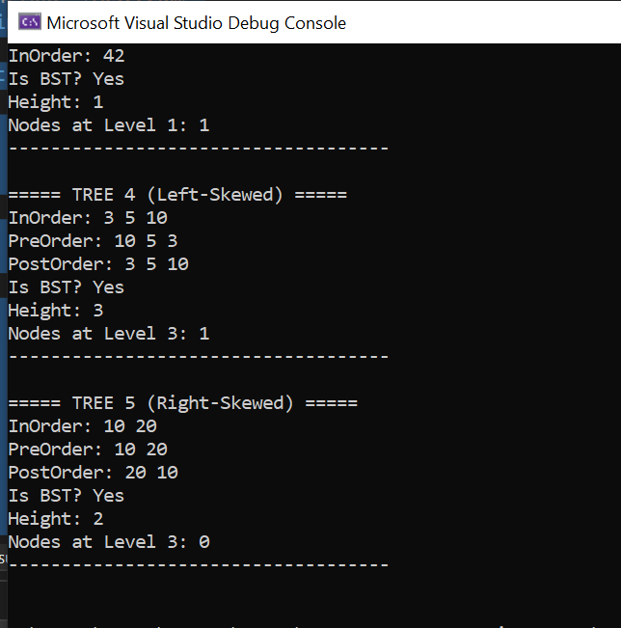

TASK#4:
#include <iostream>
#include <queue>

struct Node {
int data;
Node* left;
Node* right;

Node(int val) : data(val), left(nullptr), right(nullptr) {}
};

class BinaryTree {
public:
Node* root;
BinaryTree() : root(nullptr) {}

Node* newNode(int data) {
return new Node(data);
}

void insert(int data) {
Node* new_node = newNode(data);

// If tree is empty, the new node becomes the root
if (root == nullptr) {
root = new_node;
return;
}

// Use a queue for level-order traversal
std::queue<Node*> q;
q.push(root);

while (!q.empty()) {
Node* current = q.front();
q.pop();

// Try inserting in the left child
if (current->left == nullptr) {
current->left = new_node;
return;
}
else {
q.push(current->left);
}

// Try inserting in the right child
if (current->right == nullptr) {
current->right = new_node;
return;
}
else {
q.push(current->right);
}
}
}

void displayInOrder(Node* node) {
if (node == nullptr)
return;
displayInOrder(node->left);
std::cout << node->data << " ";
displayInOrder(node->right);
}

void display() {
std::cout << "In-order traversal: ";
displayInOrder(root);
std::cout << std::endl;
}
};

// --- Function to check if two trees are isomorphic ---
bool areIsomorphic(Node* root1, Node* root2) {
if (root1 == nullptr && root2 == nullptr)
return true;

if (root1 == nullptr || root2 == nullptr)
return false;

if (root1->data != root2->data)
return false;

return
(areIsomorphic(root1->left, root2->left) && areIsomorphic(root1->right, root2->right)) ||
(areIsomorphic(root1->left, root2->right) && areIsomorphic(root1->right, root2->left));
}

// --- Main ---
int main() {
BinaryTree T1, T2;

int valuesT1[] = { 1, 2, 3, 4, 5, 6, 7, 8, 9 };
int n1 = sizeof(valuesT1) / sizeof(valuesT1[0]);
for (int i = 0; i < n1; i++) {
T1.insert(valuesT1[i]);
}

int valuesT2[] = { 1, 3, 2, 6, 7, 5, 4, 9, 8 };
int n2 = sizeof(valuesT2) / sizeof(valuesT2[0]);
for (int i = 0; i < n2; i++) {
T2.insert(valuesT2[i]);
}

// --- Display both trees ---
std::cout << "Tree T1: ";
T1.display();

std::cout << "Tree T2: ";
T2.display();

// --- Check isomorphism ---
if (areIsomorphic(T1.root, T2.root))
std::cout << "\nThe two trees ARE isomorphic.\n";
else
std::cout << "\nThe two trees are NOT isomorphic.\n";

return 0;
}

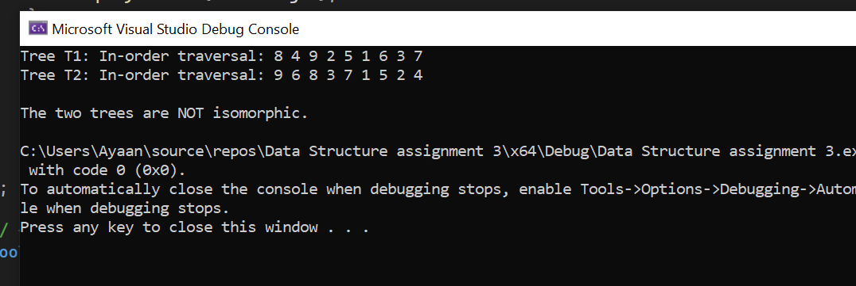
TASK#3:
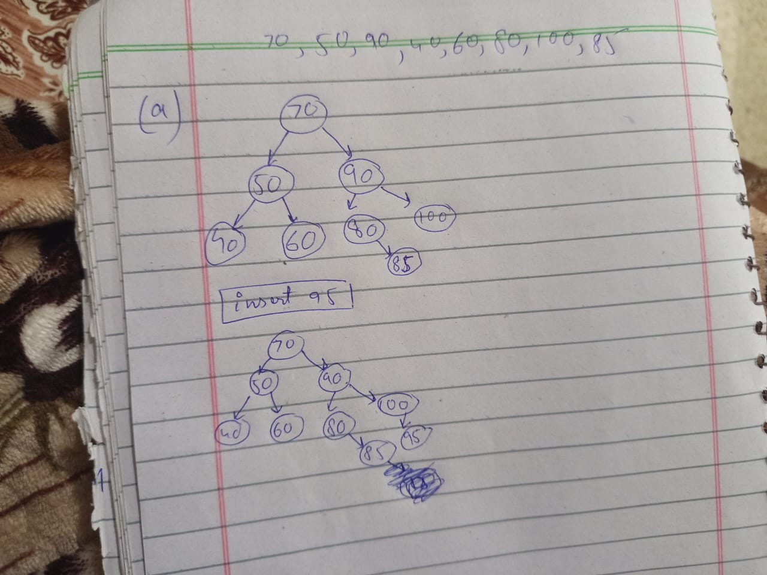
The tree is balanced and there is no unbalanced and no rotation required even after inserting the new 95 value .
TASK#4:
#include <iostream>
#include <string>
#include <algorithm>
using namespace std;

// --- linked list for songs with same frequency ---
struct songnode {
string name;
songnode* next;
songnode(string n) {
name = n;
next = nullptr;
}
};

// --- avl tree node ---
struct avlnode {
int freq;
songnode* songs; // linked list of songs with same frequency
avlnode* left;
avlnode* right;
int height;

avlnode(int f, string songname) {
freq = f;
songs = new songnode(songname);
left = nullptr;
right = nullptr;
height = 1;
}
};

// --- avl tree class ---
class avltree {
public:
avlnode* root;

avltree() {
root = nullptr;
}

int height(avlnode* n) {
if (n == nullptr)
return 0;
else
return n->height;
}

int getbalance(avlnode* n) {
if (n == nullptr)
return 0;
else
return height(n->left) - height(n->right);
}

avlnode* rightrotate(avlnode* y) {
avlnode* x = y->left;
avlnode* t2 = x->right;

x->right = y;
y->left = t2;

y->height = 1 + max(height(y->left), height(y->right));
x->height = 1 + max(height(x->left), height(x->right));

return x;
}

avlnode* leftrotate(avlnode* x) {
avlnode* y = x->right;
avlnode* t2 = y->left;

y->left = x;
x->right = t2;

x->height = 1 + max(height(x->left), height(x->right));
y->height = 1 + max(height(y->left), height(y->right));

return y;
}

// --- insert node by frequency ---
avlnode* insert(avlnode* node, int freq, string songname) {
if (node == nullptr)
return new avlnode(freq, songname);

if (freq < node->freq)
node->left = insert(node->left, freq, songname);
else if (freq > node->freq)
node->right = insert(node->right, freq, songname);
else {
// same frequency → add to linked list
songnode* temp = node->songs;
while (temp->next != nullptr)
temp = temp->next;
temp->next = new songnode(songname);
return node;
}

node->height = 1 + max(height(node->left), height(node->right));

int balance = getbalance(node);

// balance the node
if (balance > 1 && freq < node->left->freq)
return rightrotate(node);

if (balance < -1 && freq > node->right->freq)
return leftrotate(node);

if (balance > 1 && freq > node->left->freq) {
node->left = leftrotate(node->left);
return rightrotate(node);
}

if (balance < -1 && freq < node->right->freq) {
node->right = rightrotate(node->right);
return leftrotate(node);
}

return node;
}

// --- find a song by name ---
avlnode* findsong(avlnode* node, string name) {
if (node == nullptr)
return nullptr;

songnode* temp = node->songs;
while (temp != nullptr) {
if (temp->name == name)
return node;
temp = temp->next;
}

avlnode* leftsearch = findsong(node->left, name);
if (leftsearch != nullptr)
return leftsearch;

return findsong(node->right, name);
}

// --- delete a song (used when frequency changes) ---
avlnode* deletesong(avlnode* node, int freq, string songname) {
if (node == nullptr)
return node;

if (freq < node->freq)
node->left = deletesong(node->left, freq, songname);
else if (freq > node->freq)
node->right = deletesong(node->right, freq, songname);
else {
songnode* temp = node->songs;
songnode* prev = nullptr;

while (temp != nullptr && temp->name != songname) {
prev = temp;
temp = temp->next;
}

if (temp == nullptr)
return node; // song not found

if (prev == nullptr)
node->songs = temp->next;
else
prev->next = temp->next;

delete temp;

if (node->songs == nullptr) {
if (node->left == nullptr && node->right == nullptr) {
delete node;
return nullptr;
}
else if (node->left == nullptr) {
avlnode* tempnode = node->right;
delete node;
return tempnode;
}
else if (node->right == nullptr) {
avlnode* tempnode = node->left;
delete node;
return tempnode;
}
else {
avlnode* successor = node->right;
while (successor->left != nullptr)
successor = successor->left;

node->freq = successor->freq;
node->songs = successor->songs;
node->right = deletesong(node->right, successor->freq, successor->songs->name);
}
}
}

node->height = 1 + max(height(node->left), height(node->right));
int balance = getbalance(node);

if (balance > 1 && getbalance(node->left) >= 0)
return rightrotate(node);

if (balance > 1 && getbalance(node->left) < 0) {
node->left = leftrotate(node->left);
return rightrotate(node);
}

if (balance < -1 && getbalance(node->right) <= 0)
return leftrotate(node);

if (balance < -1 && getbalance(node->right) > 0) {
node->right = rightrotate(node->right);
return leftrotate(node);
}

return node;
}

// --- play a song ---
void playsong(string songname) {
avlnode* songnode = findsong(root, songname);

if (songnode == nullptr) {
cout << "song not found!\n";
return;
}

int newfreq = songnode->freq + 1;
root = deletesong(root, songnode->freq, songname);
root = insert(root, newfreq, songname);

cout << "now playing: " << songname << " 🎵 (new frequency = " << newfreq << ")\n";
}

// --- display tree in ascending frequency order ---
void display(avlnode* node) {
if (node == nullptr)
return;

display(node->left);
cout << "frequency " << node->freq << " -> ";
songnode* temp = node->songs;
while (temp != nullptr) {
cout << temp->name << " ";
temp = temp->next;
}
cout << endl;
display(node->right);
}
};

// --- main program ---
int main() {
avltree spotify;

// initial song frequencies
spotify.root = spotify.insert(spotify.root, 1, "a");
spotify.root = spotify.insert(spotify.root, 5, "b");
spotify.root = spotify.insert(spotify.root, 9, "c");
spotify.root = spotify.insert(spotify.root, 2, "d");
spotify.root = spotify.insert(spotify.root, 4, "e");
spotify.root = spotify.insert(spotify.root, 6, "f");
spotify.root = spotify.insert(spotify.root, 8, "g");
spotify.root = spotify.insert(spotify.root, 3, "h");
spotify.root = spotify.insert(spotify.root, 7, "i");
spotify.root = spotify.insert(spotify.root, 9, "j");
spotify.root = spotify.insert(spotify.root, 5, "k");

int choice;
string songname;

do {
cout << "\n--- spotify menu ---\n";
cout << "1. display all songs\n";
cout << "2. play a song\n";
cout << "3. exit\n";
cout << "enter your choice: ";
cin >> choice;

if (choice == 1) {
cout << "\n--- songs by frequency ---\n";
spotify.display(spotify.root);
}
else if (choice == 2) {
cout << "enter song name: ";
cin >> songname;
spotify.playsong(songname);
}
else if (choice == 3) {
cout << "exiting spotify... goodbye!\n";
}
else {
cout << "invalid choice.\n";
}

} while (choice != 3);

return 0;
}

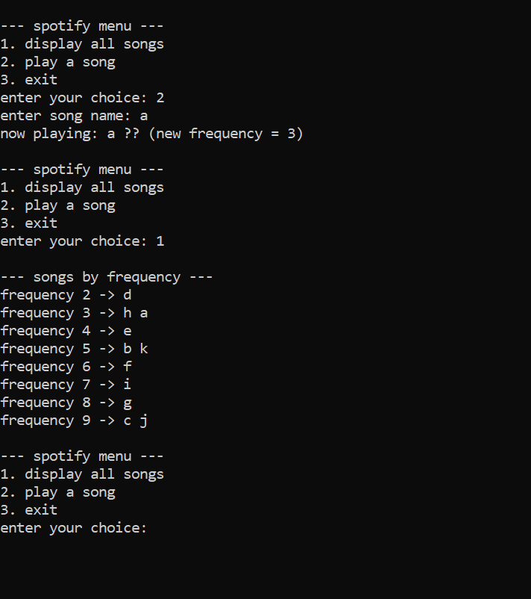

TASK#5:
#include <iostream>
using namespace std;

// --- Node structure ---
struct Node {
int data;
Node* left; // acts as 'prev' in DLL
Node* right; // acts as 'next' in DLL

Node(int val) {
data = val;
left = nullptr;
right = nullptr;
}
};

// --- Helper class for BST ---
class BST {
public:
Node* root;

BST() {
root = nullptr;
}

// Insert function for BST
Node* insert(Node* node, int data) {
if (node == nullptr)
return new Node(data);

if (data < node->data)
node->left = insert(node->left, data);
else
node->right = insert(node->right, data);

return node;
}

void insert(int data) {
root = insert(root, data);
}

// In-order traversal for checking BST
void inorder(Node* node) {
if (node == nullptr)
return;

inorder(node->left);
cout << node->data << " ";
inorder(node->right);
}
void preorder(Node* node) {
if (node == NULL)
return;
cout << node->data<<" ";
preorder(node->left);
preorder(node->right);
}
void displayInorder() {
cout << "BST In-order: ";
inorder(root);
cout << endl;
cout<< "BST pre-order: ";
preorder(root);
cout << endl;
}

// --- Convert BST to Circular Doubly Linked List ---
Node* head = nullptr;
Node* prev = nullptr;

void treeToDoublyListHelper(Node* node) {
if (node == nullptr)
return;

// In-order traversal: left -> root -> right
treeToDoublyListHelper(node->left);

// Link current node with previous
if (prev == nullptr)
head = node;
else {
prev->right = node;
node->left = prev;
}

prev = node;

treeToDoublyListHelper(node->right);
}

Node* treeToDoublyList() {
if (root == nullptr)
return nullptr;

treeToDoublyListHelper(root);

// Make it circular
head->left = prev;
prev->right = head;

return head;
}

// --- Display circular doubly linked list ---
void displayCircularDLL(Node* head) {
if (head == nullptr) {
cout << "List is empty.\n";
return;
}

Node* curr = head;
cout << "Circular Doubly Linked List: ";
do {
cout << curr->data << " ";
curr = curr->right;
} while (curr != head);
cout << endl;
}
};

// --- Main Function ---
int main() {
BST bst;

// Create BST
bst.insert(4);
bst.insert(2);
bst.insert(5);
bst.insert(1);
bst.insert(3);

bst.displayInorder();

// Convert to Circular DLL
Node* head = bst.treeToDoublyList();

// Display Circular DLL
bst.displayCircularDLL(head);

// Show circular connection
cout << "Head: " << head->data << ", Tail: " << head->left->data << endl;

return 0;
}
